LOCAL LAW NO. _______, 2026
OF THE VILLAGE OF NYACK

A LOCAL LAW AMENDING CHAPTER 360 (ZONING) OF THE CODE OF THE VILLAGE OF NYACK, IMPOSING AND ESTABLISHING A TEMPORARY MORATORIUM, SO AS TO SUSPEND LAND USE BOARD APPROVALS, ISSUANCE OF BUILDING PERMITS AND THE PROCESSING OF SAME, WITHIN THE ROUTE 59 CORRIDOR
(10/23/2026 DRAFT)

Be it enacted by the Board of Trustees of the Village of Nyack as follows:

Section 1 - Legislative Authority, Purpose and Intent:

This Local Law is adopted pursuant to New York State (“NYS”) Municipal Home Rule Law (“MHRL”) §10; and in accordance with the procedures prescribed in MHRL §20, and NYS Village Law §4-412(1)(a), §7-700, §7-704, §7-706, §7-708 and §21-2100. The Board of Trustees (“Village Board”) of the Village of Nyack (“Village”) is undertaking a comprehensive planning and zoning study of the Route 59 corridor that may substantially alter permitted uses, density, dimensional standards, site design, streetscape requirements and redevelopment opportunities. Development under existing regulations, during this limited planning period, could result in improvements or land use patterns inconsistent with the emerging comprehensive framework, and could impair opportunities for coordinated redevelopment, assembly of parcels into a larger space for redevelopment, infrastructure improvements and implementation of a resultant plan. As such, the Village Board recognizes the need to review and amend the Village’s Comprehensive Plan, and to conform its zoning regulations to the Comprehensive plan, and also to the NYS laws governing land use and zoning.

Section 2 - Legislative Findings:

The Village Board finds that appropriate measures must be taken to secure a temporary reasonable halt on development, subdivisions, building permits and approvals for land development, within the study areas, to protect the public interest while the Village completes its review of, and potential revisions to, the Village’s Comprehensive Plan and Zoning Code (Chapter 360 of the Village Code), including any necessary compliance with the analysis and procedures mandated by the State Environmental Quality Review Act (“SEQRA”).

Without a temporary halt on land development, certain residential building permits, and approvals for development, there is the potential that undesirable development could be located in the study area, which would be unsuitable, or incompatible, with the goals and objectives of the Comprehensive Plan and Zoning Code text amendments. By maintaining the status quo on all land development, until such time as appropriate consideration is deliberated, and potential amendments to the Zoning Code and revisions to the Comprehensive Plan are adopted, the Village Board will be enabled, by this moratorium, to provide for the planned orderly growth and development of the Route 59 corridor.

The Village Board has retained the services of a planning consultant (BFJ Planning) to provide recommendations regarding review of, and amendments to, the Comprehensive Plan and Zoning Code text, and to provide a draft of a revised Comprehensive Plan, for the Route 59 corridor. The Village Board also created an advisory board of residents, and members of various Village land use boards, including the Village Board, to assist the planning consultant. The planning consultant and advisory board have worked diligently, and anticipate a draft Comprehensive Plan for the Route 59 corridor, and recommended Zoning Code text changes, to be submitted to the Village Board by June 30, 2027. Therefore, the Village Board has determined that this above-described moratorium should be adopted for a finite amount of time in order to allow the planning consultant and advisory board to complete their work.

Section 3 – Chapter 360 (Zoning), of the Code of the Village of Nyack, is amended to the extent only of adding a new “Article VII,” which new “Article VII” shall be entitled “Route 59 Corridor Moratorium,” and shall read as follows:

Article VII. Route 59 Corridor Moratorium

§ 360-6.2. Moratorium Imposed; Applicability.

- A moratorium on all Village land use board approvals, and all building permits, as set forth below, is hereby imposed.

Geographic Applicability: This moratorium shall apply solely to those properties within the Village identified on the map entitled “Route 59 Corridor Moratorium Area,” dated [DATE], attached hereto as Schedule A and incorporated herein by reference. The properties subject to this moratorium shall also be identified by their respective Town of Orangetown Tax Map parcel numbers set forth in Schedule B. In the event of any discrepancy between the Schedule A map and the Schedule B Tax Map parcel list, the Schedule B Tax Map parcel list shall control. These aforesaid properties (Schedule A and Schedule B) shall comprise, and hereinafter be referred to as, the “Moratorium Area.” No property outside the Moratorium Area shall be subject to the moratorium restrictions established by this Local Law (Article VII).

- The moratorium established by this Local Law (Article VII) shall expire, without further action of the Village Board, on June 30, 2027, and thereafter shall be of no further force or effect. However, if it appears that any required review and study, referred to hereinabove, will not be completed by June 30, 2027, then the Village Board may, by Resolution, extend the period of this Moratorium for up to a maximum of an additional two three-month extensions.

- Scope: Other than as exempted in subsection “E” below, no Village board, agency or department shall process, hear, approve, issue, grant or sign any new, or any pending, preliminary or final site development plan, preliminary or final subdivision plat, special permit, variance, or any land disturbance or grading permit, erosion and sediment control permit, floodplain development permit, and water connection permit.

- To the extent that any provision of NYS law imposes a time frame for action by a municipal agency, entity, board or body, so that a default approval will result from any inaction by the municipal agency, entity, board or body, then the time for any action required by the municipal agency, entity, board or body shall be, and is, hereby extended until this moratorium has, and any and all extensions thereof have, fully expired. Therefore, no default approval shall be deemed to have occurred or transpired with regard to any application for any approval concerning any type of land use development by reason of this moratorium being in effect. Should any NYS law preempt this provision, then the Village Board’s adoption of this Local Law (Article VII) shall be deemed to constitute a denial, without prejudice, of any such land use application or relief sought by any land use applicant, with said application or relief being deemed as ready for resubmission and reconsideration ninety days after the date of the expiration of this moratorium or of any and all extensions thereof.

- Exemptions:

The following types of land use applications, Building Department processing, land use board reviews, permits, grants and approvals shall be exempt from this moratorium, and may be considered and acted upon during the moratorium:

  - The issuance of building permits to a property that has received final site development plan approval, final special permit approval, or final subdivision plat approval (“land use board final approval”); provided, however, that said property is under development at the time of the adoption of this Local Law (Article VII), and also provided that the land use board final approval has not expired or lapsed.

  - Small or minor projects, such as restoration, alteration or renovation of facades without expansion, extension or enlargement of the facade, tenant fit-outs, signs, awnings and windows, provided the work does not expand, extend or enlarge the building, change its use, or increase density.

  - The project located at 47 Route 59 (the Super 8 motel – 65.35-1-9 and 65.25-1-6), for which there is an active Building Permit allowing the interior renovation of the hotel, including hotel rooms.

  - Consideration, and approval, by the Village’s Zoning Board of Appeals of an application for an area variance, or for an interpretation, but not for any approvals that facilitate otherwise prohibited development.

  - Issuance of a ministerial permit, such as, but not limited to, a Building Permit issued for the purpose of complying with the NYS Uniform Fire Prevention and Building Code, or to remedy a code violation, or other work needed for safety and accessibility improvements; tree removal permit; sign permit; or a Certificate of Compliance issued under Chapter 140 of the Village Code, which is issued solely for the purpose of documenting compliance with the NYS Uniform Fire Prevention and Building Code.

  - Approval of a Lot Line Change (property boundary adjustment), provided that said adjustment does not increase the size of any lot by greater than ten percent (10%).

  - Approval of an addition, alteration or reconstruction of an existing building or structure, which results in no greater than a ten percent (10%) increase in the square footage of such building or structure, and which is not intended or designed to alter the approved or legal use and occupancy, nor accommodate any new or different use, of such building or structure.

  - Approval of a land use application that has been issued a Negative Declaration pursuant to the State Environmental Quality Review Act (SEQRA), by the Lead Agency, as of the date of adoption of this Local Law (Article VII) effectuating this moratorium.

- Any land use applications for board approvals or permits, which are filed after the date of adoption of this Local Law (Article VII) effectuating this moratorium, and which are not exempted from this moratorium, shall be filed at the risk of the applicants and shall not be processed, granted, approved or issued until this moratorium has fully expired.

- During the period of the moratorium, the Village Board shall endeavor to complete all reasonable and necessary reviews, studies, analyses and, if warranted, revisions to the Village Zoning Code.

§ 360-6.3. Administrative Relief from Moratorium.

- In order to avoid the improper taking of property, and to prevent irreparable harm, the Village Board is authorized to grant limited relief from this moratorium pursuant to the standards and requirements herein. An applicant seeking such relief shall be required to show, by clear and convincing evidence, including credible “dollars and cents” financial proof, that (i) the applicant cannot make any reasonable use of its property with any of the uses permitted in the relevant Zoning District; (ii) the moratorium causes irreparable injury to the applicant; and (iii) it would be unreasonable and unjust not to grant relief from the moratorium. Any relief granted by the Village Board shall be the minimum necessary, and the Village Board may impose conditions on any relief granted.

- All applications for relief from the moratorium shall be treated as Unlisted Actions under SEQRA, and the Village Board shall be the Lead Agency for such applications for relief.

- In the event that relief from the moratorium is granted by the Village Board, the applicant shall proceed to other required Village board(s), if any, to apply for the required development approvals (if any). Notwithstanding any relief granted, pursuant to this section, a development approval shall not be granted unless the approved application complies with all Village Zoning Code regulations and all other Code requirements in effect on the date of approval.

§ 360-6.4. Notice to Applicants; Change in Zoning Requirements.

This §360-6.4, of this Article VII, provides notice to all applicants that, although an application authorized in § 360-6.3 above may proceed through the Village’s Planning Board and/or Zoning Board of Appeals review process, the applicant proceeds at its risk, because such application may be impacted or denied because of a change in Site Development Plan, Subdivision, Special Permit and/or other planning, land use and/or zoning regulations and requirements (“Zoning regulations”). A land use approval shall not be granted unless the proposed application complies with all Zoning regulations in effect on the date of approval.

§ 360-6.5. Effect on Other Laws.

To the extent that any NYS statute, law, ordinance, rule or regulation, or parts thereof, including Article 16 of NYS Village Law, are in conflict with any provision of this Article VII, this Article VII shall control and govern.

§ 360-6.6. Severability.

If any part or provision of this Local Law (Article VII), or the application thereof to any person or circumstance, is adjudged invalid or unconstitutional by a court of competent jurisdiction, such judgment shall be confined in its operation to the part, provision or application directly involved in the controversy in which such judgment shall have been rendered and shall not affect or impair the validity of the remainder of this Local Law (Article VII), or the application thereof to other persons or circumstances. The Village Board of Trustees hereby declares that it would have enacted the remainder of this Local Law (Article VII) even without any such invalid or unconstitutional part, provision or application.

§ 360-6.7. Supersession of Inconsistent Laws, if any.

The Village Board hereby declares its legislative intent to supersede any provision of any other Village Local Law, or of any NYS statute, law, rule, code or regulation (“law”) that may be inconsistent, or in conflict, with this Local Law (Article VII). The NYS law that shall be, and hereby are, superseded include, but are not limited to, all of Article 16 of NYS Village Law, and any other provision of law that the Village may supersede pursuant to the NYS Municipal Home Rule Law and the Constitution of the State of New York. The courts are specifically requested to take notice of this legislative intent, and apply such intent in the event that the Village has failed to specify any provision of law that may require supersession. The Village Board hereby declares that it would have enacted this Local Law (Article VII), and superseded such provision, had it been apparent.

Section 4 – Effective Date:

This Local Law (Article VII) shall take effect immediately upon the filing of a copy with the NYS Secretary of State in the manner prescribed by NYS Municipal Home Rule Law §27.

Appendix A

Map - Black boundary line shows area of moratorium proposed.

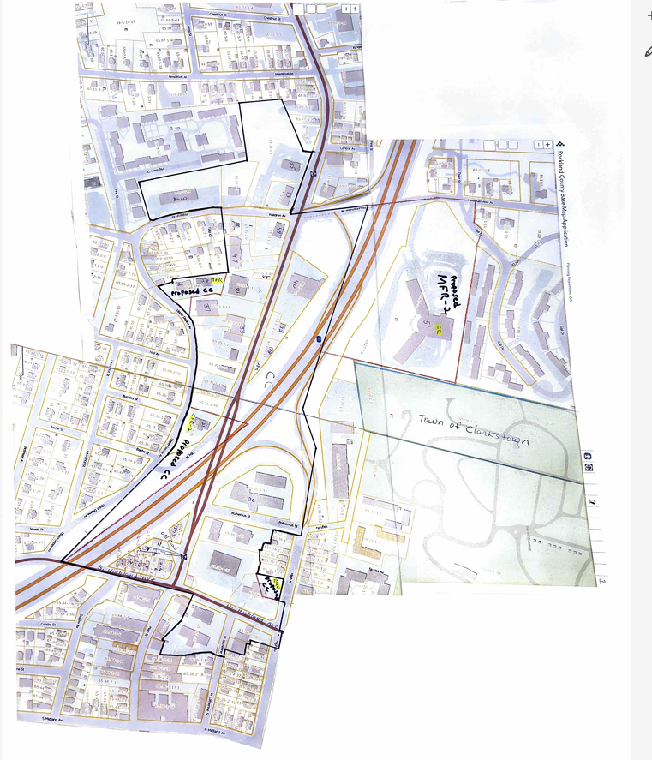
Appendix B

List of Parcels in the Uptown Gateway Zoning Study

South Highland Ave/Kilby Street
2-4 South Highland Ave. 65.36-1-32
6 South Highland Ave. 65.36-1-33
8 South Highland Ave. 65.36-1-34 and 9 Route 59 65.36-1-34
10 South Highland Ave. 65.36-1-35 and 7 Route 59 65.36-1-35
12 South Highland Ave. 65.36-1-36
14 South Highland Ave. 65.36-1-37
11 Route 59 65.36-1-31
13-17 Route 59 65.36-1-30

West Gate Inn
26 Route 59 65.36-1-51

Route 59 (South Side), Kilby Street and Waldron Ave.
21 Route 59 65.36-1-48 (Kilby Street – SFR-2 to CC)
33 Route 59 65.35-1-14 (CC)
37 Route 59 65.35-1-13 (TFR/CC)
26-28 Upper Depew Ave. 65.35-1-12 (TFR)
41 Route 59 65.35-1-11 (CC)
45 Route 59 65.35-1-10
47 Route 59 65.35-1-9 (Super 8 Motel)
49 Route 59 65.35-1-7 (Chase Bank)
1 Waldron Ave 65.35-1-6 (part of Super 8 property)
3 Waldron Ave 65.35-1-5 (faces Waldron Ave.)
8-10 Waldron Ave 65.35-1-4 (medical offices)
55 Route 59 65.35-1-1 (McDonalds)
53 Route 59 65.35-1-2 (gas station)

Route 59 (North Side)
40 Route 59 65.35-1-21 (Old World Food Market)
32 Route 59 65.35-1-20 (auto store – for sale)
28 Route 59 65.35-1-19 (Tree House – Cannabis store)
28A Route 59 65.35 -1-18 (part of Tree House property)
51 Mountainview Ave 65.27-1-1 (Tappen Zee Manor) (include in the Study)

